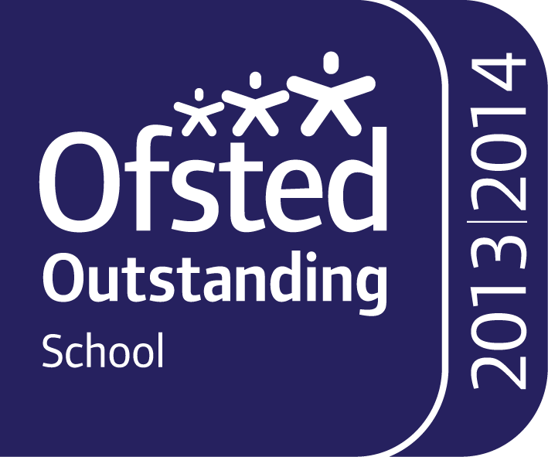

Brampton Road Headteacher – Mrs AC Benbow
Wath-upon-Dearne Brampton-ellis-cofe.primary@rotherham.gov.uk
ROTHERHAM. www.bramptonellis.org.uk
S63 6BB Telephone: 01709 760370

Dear Parent/Carers

Within the JMAT, Brampton Cortonwood Infant School have a school dog. Her name is Luna and she’s a one year old cocker spaniel. She works with the children as an incentive for reading, attendance and physical development. We intend on having Luna to visit on a weekly basis.

The JMAT have undertaken a significant amount of research and are aware of many benefits to having a school dog:

• A calming effect on pupils, particularly those with behavioural or learning difficulties;
• Improved behaviour and concentration reduce stress and improved self-esteem;
• Encouraging expression and participation in more withdrawn children;
• Fostering a sense of responsibility;
• Increasing enthusiasm for and enjoyment of animals which will motivate the children to think and learn;
• Encouraging respect and thereby improving pupils’ relationship with each other, parents and teachers;
• Teaching children to nurture and respect life;
• Helping work undertaken with the most vulnerable children and educational improvements with low achievers;
• Helping children build confidence in reading;
• Helping children who suffer bereavement or who are upset in any way and in need of calm, comfort and space before being able to tell an adult what has upset them.

She will also be available to work with children who may have had bad experiences with dogs or other animals. With parental permission, over a period of time children who react fearfully to dogs will be supported in approaching, handling and gaining confidence in managing their fear.

While the dog’s main place of residence will be Mrs Marrow’s office, which is secure and separate from the classrooms, children will be able to interact with the dog under strict supervision at certain times of the day/week as long as parental permission has been given. The dog will not be given access to other visitors without supervision and mutual consent.

A cocker spaniel was chosen as this breed is known to be child friendly, lively, gentle mannered, demonstrably affectionate yet sensitive and have an outstanding trainability. This breed of dog has short hair and so there is a reduced risk of allergic reaction too.

Please complete the consent form overleaf and return it to the school office as soon as possible. We will not let children interact with Luna until consent forms have been received.

We look forward to Luna’s first day at school,

Brampton ‘The Ellis’ Primary






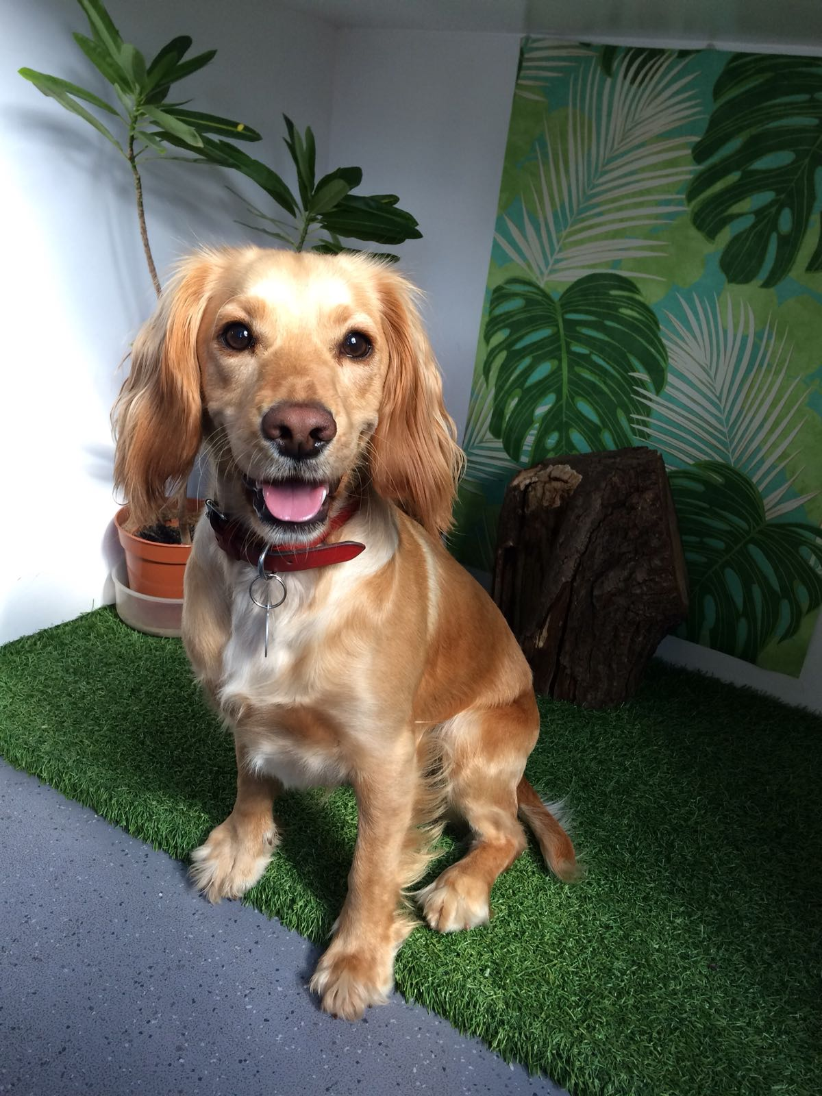

…………………………………………………………………………………………………………………………………………………………………………………………….

Child’s Name __________________________________________ Class __________________________________

Please delete as appropriate

I give / do not give permission for my child to interact with Luna.

My Child has a fear of dogs and I do not wish them to interact with Luna in a group or 1.1 basis (however, it is unavoidable that on occasion your child may pass Luna on the corridor).

My child has a fear of dogs and I would like the school to help manage the fear by interacting with Luna on a 1.1 basis.

My child has/has not got an allergy to pet hair

Signed ____________________________________ (Parent / Carer)

